
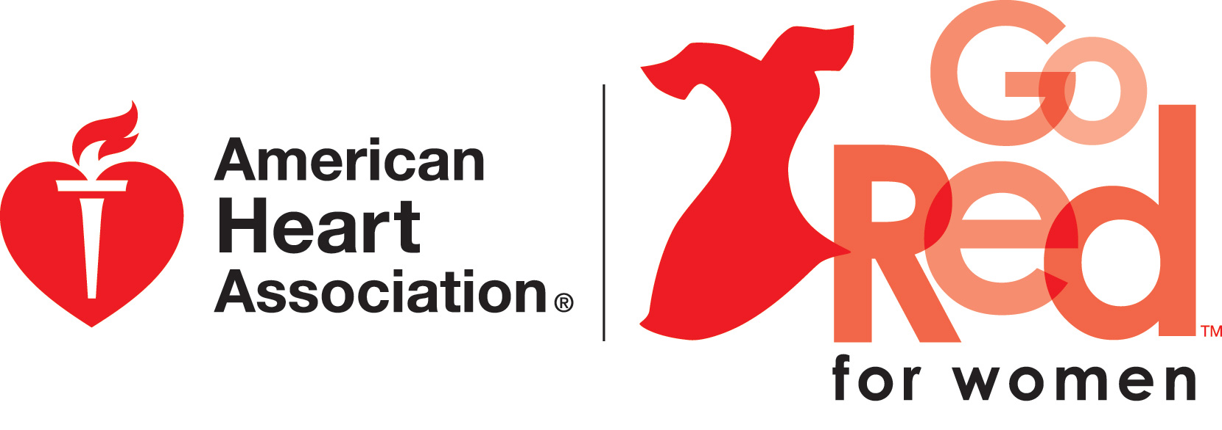
C/o Charla Davidson
2208 Avenue N
Nederland, TX 77627
www.heart.org

What is Circle of Red?
An elite group of women (and men) who have the influence and resources to significantly impact the community by providing a personal commitment to help find a cure for the number one killer of women.

Who is a Circle of Red Member?
An individual who can provide a personal commitment of $1,000.00

What Benefits my participation as a Circle of Red Member? ¹
- Help fund research grants needed to find a cure for Golden Triangle’s number one killer of women
- Decrease the number of child deaths under the age of 15 (2,100 total annual deaths) due to congenital heart defects
- Increase continuing medical education (CME) programs to help physicians incorporate the AHA’s guidelines for preventing heart disease among women
- Increase AHA’s CPR in Schools programs, where an estimated 200,000 kids have been trained and many lives have been saved.
- Increase the awareness and prevention. “Of women who die, one in 29 die of breast cancer. About one out of every 2.4 women dies of heart disease, stroke and other cardiovascular diseases.”

Recognition as a Circle of Red Member
- VIP seating for FOUR (4) at Go Red for Women Luncheon (May 1, 2012)
- Special verbal recognition during the Go Red for Women Luncheon Event
- Profile displayed throughout Golden Triangle Luncheon Event (invitations, media, billboards if group desires)
- VIP Invitation to at least two Circle of Red only events
- Special recognition in Go Red for Women Luncheon Programs

